**Question 1 (10 marks)**

**The data file 'Deer' contains measurements on the weight gain of individuals of an endangered species, Père David's deer. Groups of six animals were raised on each of four different diets and their weight gain (kg) measured after one year. All the animals were kept in the same field, individual deer being uniquely tagged and individually fed by the researchers.**

Data variables are a) diet a - d; and b) gain is weight gain (kg) per year.

**Using appropriate graphical and statistical analysis:**

1. **Conduct an appropriate statistical analysis to test the null hypothesis that diet does not influence weight gain. Report the results using an appropriate statistical sentence.**
2. **Draw boxplots to explore the variability in the weight gain for each diet. Paste these boxplots and provide an appropriate figure legend.**
3. **Calculate and report the means and standard errors for the weight gains for the individual diets.**
4. **Write a short summary describing the effect of diet on the weight gain of the deer, by interpretation of your statistical analysis, the boxplots and the means. Ensure that your summary describes the results of the statistical test of the null hypothesis and addresses any underlying assumptions of your analysis.**

Insert answer here:

1.

Analysis of Variance Table

Response: gain

Df Sum Sq Mean Sq F value Pr(>F)

diet 3 717.65 239.216 7.725 0.00128 **

Residuals 20 619.33 30.966

---

Signif. codes: 0 ‘***’ 0.001 ‘**’ 0.01 ‘*’ 0.05 ‘.’ 0.1 ‘ ’ 1

Tukey multiple comparisons of means

95% family-wise confidence level

Fit: aov(formula = deer2)

$diet

diff lwr upr p adj

b-a 11.503333 2.5108768 20.495790 0.0093079

c-a -1.436667 -10.4291232 7.555790 0.9694127

d-a 8.388333 -0.6041232 17.380790 0.0729331

c-b -12.940000 -21.9324566 -3.947543 0.0033955

d-b -3.115000 -12.1074566 5.877457 0.7679672

d-c 9.825000 0.8325434 18.817457 0.0291232

There is a significant difference in weight gain across the 4 diets (F=7.725, df=3,20, *p*<0.01). There were significant differences between diets a and b (Tukey HSD, *p*<0.01), diets b and c (Tukey HSD, *p*<0.01) and diet c and d (Tukey HSD, *p*<0.01).

2.

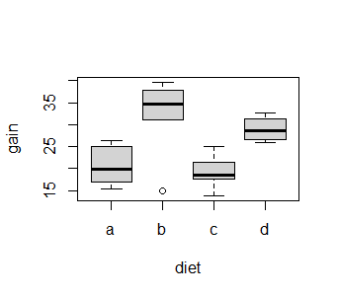

Figure 1. Weight gain in deer across 4 different diets.

3.

|  |  |  |
| --- | --- | --- |
| Diet | Mean | SD |
| A | 20.63 | 4.52 |
| B | 32.13 | 9.08 |
| C | 19.19 | 3.77 |
| D | 29.02 | 2.60 |

4.

The data was checked for normality using a histogram and was deemed to be normally distributed. There is a significant difference in weight gain across the 4 diets (F=7.725, df=3,20, *p*<0.01). There were significant differences between diets a and b (Tukey HSD, *p*<0.01), diets b and c (Tukey HSD, *p*<0.01) and diet c and d (Tukey HSD, *p*<0.01). Diet b (mean=32.13) had the highest weight gain, followed by diet d (mean=29.02), diet a (mean=20.63) and then diet c (mean=19.19).

**Question 2 (10 marks).**

**Food supplements that can be added to rice-based meals that induce feelings of higher satiety and thus lower the desire for lower starch intake. These supplements require the use of the amino acids glutamate and lysine in their production. Researchers studied the effect of a new fermentation process on amino acid production in small-scale industrial conditions. Amino acids were produced simultaneously under fermentation and yields were expressed in g l-1 of batch culture. The data are given in the file 'Fermentation.xlsx' for a large number of replicated batches. Fermentation processes ('Process') are coded as 1 = old and 2 = new.**

**Using appropriate graphical and statistical analysis, investigate:**

1. **Examine the differences in yields of each amino acid under BOTH the new and old process.**
2. **Write a brief summary of the effects of the change in fermentation process on glutamate and lycine yield, backing up your conclusions with statistical summary statements.**

Insert answer here:

The data was examined using a histogram and was determined to be approximately normally distributed. Glutamte yield was significantly higher under the old, compared to the new process (t-test=3.0096, df=51.774, *p*<0.01; Figure 2).

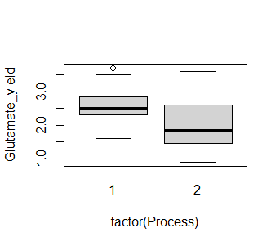

Figure 2. Glutamate yield under both the old (1) and new (2) process.

There was no significant difference in lysine yield between the old and new processes (t-test=0.86184, df=53.912, *p*=0.3926; Figure 3).

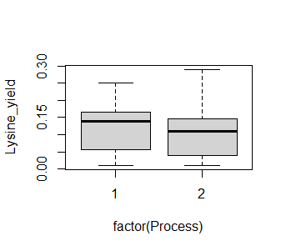

Figure 3. Glutamate yield under both the old (1) and new (2) process.

The statistical and graphical results suggest that the old process doesn’t affect lysine yield but significantly increases glutamate yield. It would therefore be beneficial to continue with the old process.